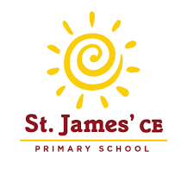

**FLOURISH Children and Families Minister**

**Salary: £15,000 per annum**

**Hours: 24 hours per week, term time only, for 2 years. To include some evening work and weekends. Weekday hours are negotiable.**

**Closing Date: Friday 20 September 2024  
Interviews: week commencing 30 September 2024**

Are you passionate to see children and families flourishing through a loving relationship with Jesus?

Are you driven to support them to discover Jesus in an accessible and fun way that deepens their relationship with God?

If so, our children, congregation and school will warmly welcome you.

This exciting role involves creating a new worshipping community at St James Primary School outside teaching hours which is invitational and intergenerational in nature. You will build a team and nurture relationships with children and their families as the co-creators of this worshipping community. If you enjoy introducing people to Jesus and giving them opportunities to grow and mature in their faith in him, we would love to hear from you.

**How to apply for the job:**

View the Job description and apply [here](https://www.cofepathways.org/members/modules/job/detail.php?record=7532)

If you want to have an informal discussion about the role, please do get in touch with [Jo](mailto:Jo)anne Gavin (Mission Support Officer for Children and Young People) by email at joanne.gavin@southwark.anglican.org